**Snowflake Health Check Guide**



|  |  |
| --- | --- |
| Product Version | 4.8.0 |
| Document Type | Health Check Preparation Guide |
| Authors | Snowflake Data source Team |
| Reviewer | Red Team & Architects |
| Approver | CTO |
| Total Pages | 10 |
| Document Status | Draft |

Table Of Contents

1.1 Objectives 2

1.2 Architecture 2

1.3 Pre-requisite 2

1.4 Download Snowflake Metadata for health check. 3

1.5 Output Files 5

Document Version Record

|  |  |  |  |
| --- | --- | --- | --- |
| Date | Version # | Author | Remarks / Reason |
| 02-May-23 | 1.0 | Dev Team | New Document |

## Objectives

Health check download for snowflake unravel product.

## Architecture

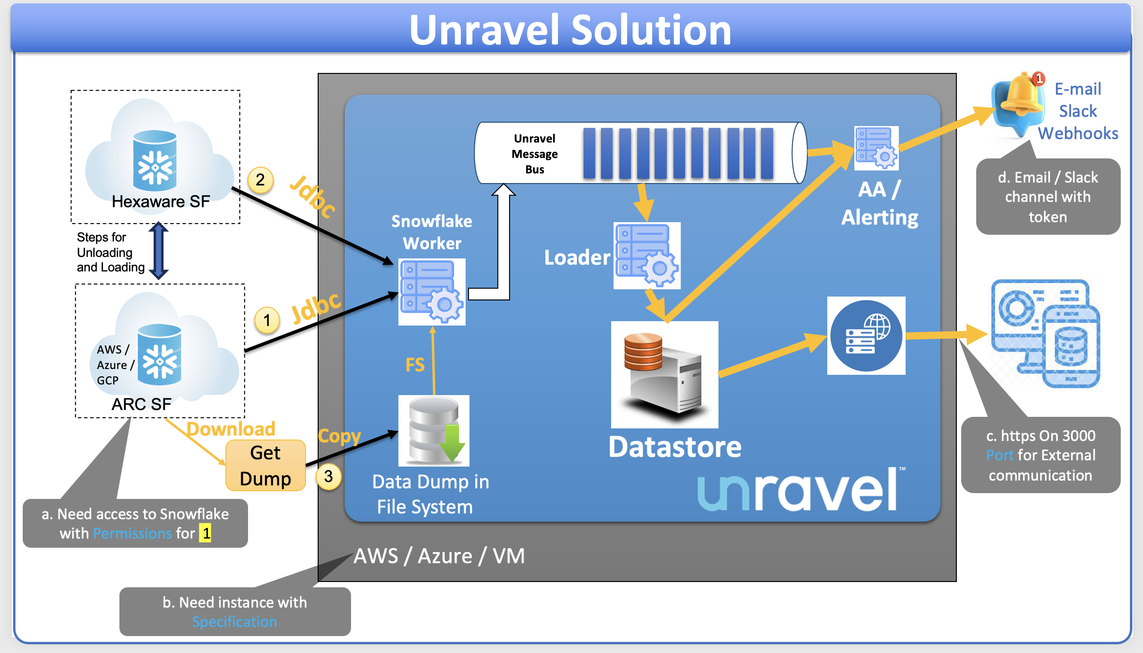

## Pre-requisite

1. **Snowflake account Access** 
   1. Health check data upload from snowflake
      1. User should have permission to create stage and file format.
      2. Snowsql 1.2.27 should be installed
      3. Required a database and schema to upload the new data.
      4. Required a user with create/delete table, insert data permission to the above created role.

## Upload Snowflake Metadata for health check.

The following scripts let you upload the account usage information to your Snowflake account.

* **prepare_schema.sql**: Create the required tables in the specified database/schema.
* **snowsql_upload_data.sql**: Uploads Snowflake data downloaded from customer environment to the specified database/schema.

Do the following to upload Snowflake metadata:

1. Download the download/upload scripts from this location:

<https://github.com/unraveldata-org/snowflake-data-loader/tree/main/script>

1. Using SnowSQL connect to a Snowflake account. This account must have access to creating **stage** and **file** format.
2. Execute the snowsql_upload_data.sql script with the required arguments to upload the metadata to Snowflake. Refer to the following list of arguments for more details:

**Step-1**:

Login to snowsight and execute the create table script - **prepare_schema.sql**.

Once the stored procedure got created, execute the stored procedure with the command:

call prepare_replication_schema(DbName, SchemaName);

For example:

call prepare_replication_schema ('testdb1', 'testschema1');

| Parameter | Description |
| --- | --- |
| DbName | Name of the DB, under which customer data need to replicate. |
| SchemaName | Name of the schema, under which customer data need to replicate. |

After the script is executed, the database & the schema gets created.

**Step-2**:

Execute the snowsql_upload_data.sql script with the required arguments to upload all the data downloaded in the above 3 steps. Refer to the following list of arguments for more details:

snowsql -f /opt/script/snowsql_upload_data.sql -d $*{db}* -s $*{schema}* -r $*{role}* -a $*{account}* -u $*{user}* -w $*{warehouse}* -o variable_substitution=true -o log_file=/opt/script/snowsql_upload_data.log --variable path=$*{path}* --variable stage_name=${unravel_stage_upload} --variable file_format=${unravel_file_format_upload}

For example:

snowsql -f /opt/script/snowsql_upload_data.sql -d testdb1 -s testschema1 -r accountadmin -a rtb81672.us-east-1 -u smajumdar -w UnravelData -o variable_substitution=true -o log_file=/opt/script/snowsql_upload_data.log --variable path=/opt/unraveldata/ --variable stage_name=unravel_stage_upload --variable file_format=unravel_file_format_upload

| Parameter | Description |
| --- | --- |
| -f | Specify the file name of the script that is executed. Either specify the fully qualified name or just filename from the current directly.  For Windows: Please put the parameter value in double quotes (“”) |
| -d | Specify the target Snowflake Account database name. This database should have rights to create stage & file-format. |
| -u | Specify the target Snowflake Account User name. This schema should have rights to create stage & file-format. |
| -s | Specify the target Snowflake Account Schema name. |
| -r | Target Snowflake Account Role |
| -a | Specify the target Snowflake Account name |
| -o variable_substitution | Enable the variable substitution switch in the script. Some variables are used in the script for which the values must be passed from the CLI. Set this to **true**. |
| -o log_file | Specify the name of log file that must be generated on command execution. |
| --variable path | Specify the local path to where the snowflake system metadata is downloaded or copied. |
| --variable stage_name | Specify the stage name, which is used to keep the temporary files for upload. |
| --variable file_format | Specify the file format name, which is used by the upload scripts. |
| -o | Provide the output related arguments to get the logs in the specified path and format. |

## Video Guide

<https://github.com/unraveldata-org/snowflake-data-loader/blob/main/Resources/Snowflake%20health%20check%20upload%20guide.mov>